**HH 7 11**

Key:

Knee: the x value that the knee module picks out as the “knee point”

Count: dummy variable

0finder: attempt to find root in deriv (index)

0finder: attempt to find root in deriv (x value)

Chosen root: 0finder was sometimes inaccurate, so I adjusted accordingly to move it closer to the actual root (unfortunately, done “by eye” based on graph right now)

7:

knee: 2.611229409872138

count: 498.0

0finder: [21]

0finder: 2.098799509212488

chosen root: 3.746525270821957

8:

knee: 1.9126661501840079

count: 200.0

0finder: [197]

0finder: 3.040014336080324

chosen root: 2.8227700078200195

9:

knee: 1.8856350723591746

count: 100.0

0finder: [84]

0finder: 2.155979150583539

chosen root: 2.484590594612506

10:

knee: 2.1566417526371575

count: 100.0

0finder: [98]

0finder: 2.857621525863148

chosen root: 2.672034531491617

11:

knee: 1.6894024609636027

count: 100.0

0finder: [89]

0finder: 2.0651802445264678

chosen root: 2.3692257134406223

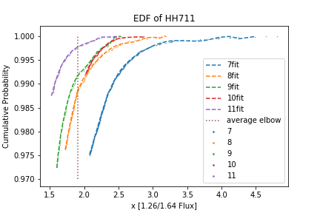

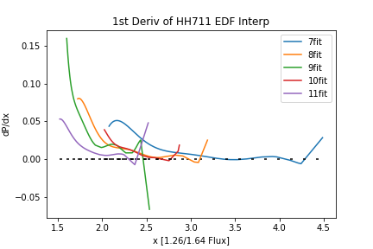

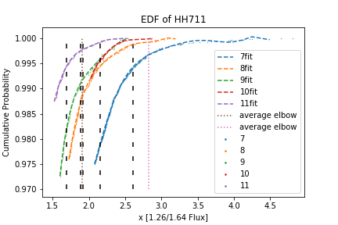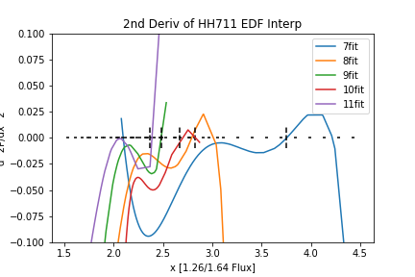

**HH6**

1:

knee: 1.8552021638435836

count: 200.0

0: [194]

0: 2.376627424863289

chosen root: 2.376627424863289

2:

knee: 1.5949992858008821

count: 200.0

0: [196]

0: 2.240420368805454

chosen root: 2.240420368805454

3:

knee: 1.6354191577648045

count: 309.0

0: [307]

0: 2.574378674663291

chosen root: 2.574378674663291

4:

knee: 1.6585240631372518

count: 309.0

0: [307]

0: 2.9271488349132198

chosen root: 2.7874149472048373

5:

knee: 1.7360633359903375

count: 136.0

0: [123]

0: 2.3521014359667047

chosen root: 2.950566009664173

6:

knee: 1.881429102558623

count: 200.0

0: [187]

0: 2.59594132348808

chosen root: 3.288854251624315

7:

knee: 1.5431200057350107

count: 304.0

0: [302]

0: 2.399211839180176

chosen root: 2.45

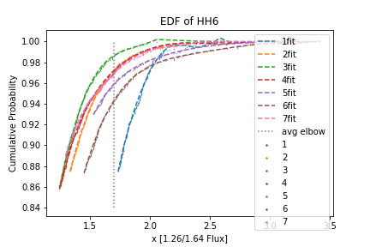

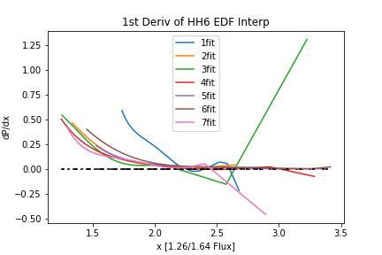

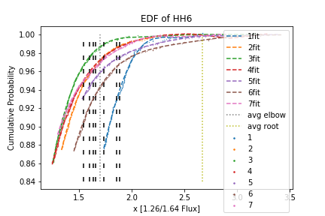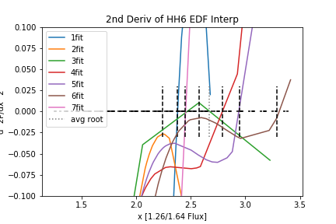

**Other HH Objects**

Hh13:

knee: 2.9385841164388222

count: 8119.0

0: [7838]

0: 5.714485043674959

Hh15:

knee: 2.8836382455016607

count: 8128.0

0: [7762]

0: 5.639874769909272

Hh341: 1.0770775196186122

knee: 3.029026608044293

count: 7687.0

0: [7574]

0: 8.23853636294484

Hh5: 1.643272321973172

knee: 3.000182810685408

count: 7999.0

0: [7800]

0: 6.719204355718435

